Step 1: create an instance on aws (ubuntu)

* Update your instance and install awscli

# sudo su

# apt update -y

# apt install awscli -y

Step 2: Go to your aws and create access keys

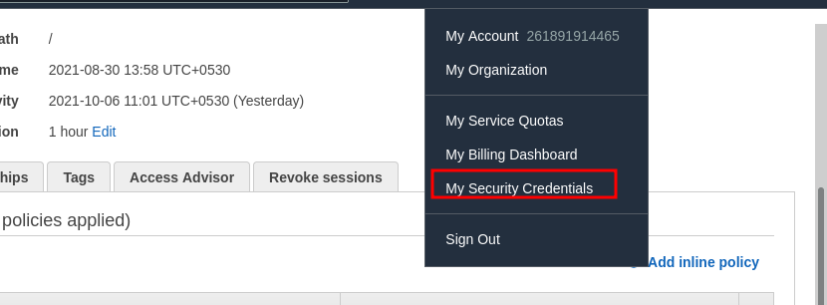

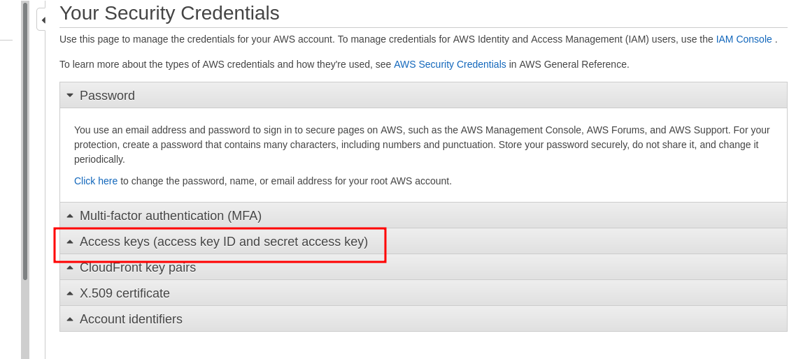

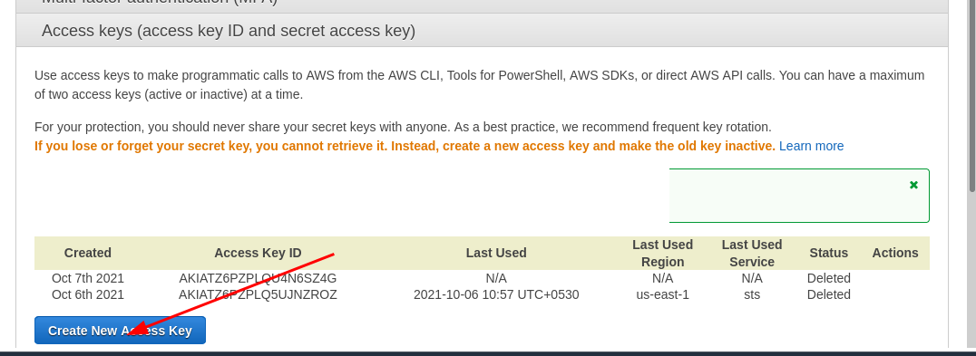

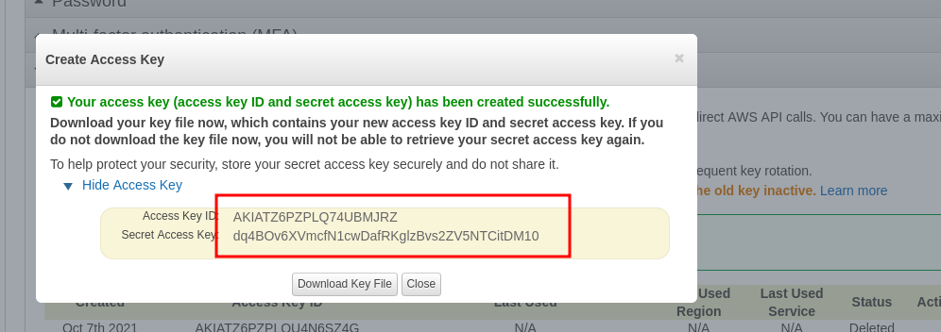

* After that go back to your ubuntu vm that you created and configure it

# aws configure

* Copy and paste access key and security key and skip region or you can configure it according to your usage

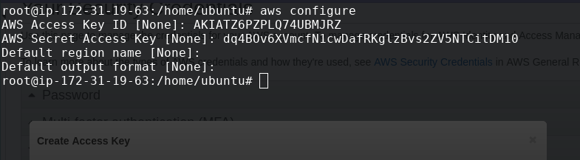

* Paste these commands and install kubectl

# snap install kubectl --classic

# kubectl

* Conncet to your eks

# aws eks --region region update-kubeconfig --name cluster_name

Eg. aws eks --region us-east-1 update-kubeconfig --name cluster1

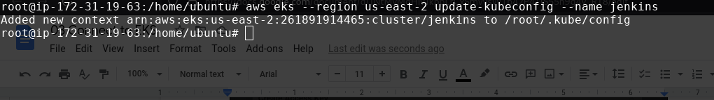

# kubectl get nodes

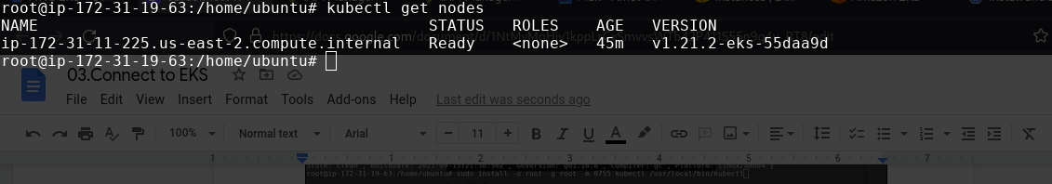

Kubectl get nodes

Sows 1c node